Minutes
Bluemont Executive Committee
Wednesday, July 28 2021 7 PM
Via Zoom

The meeting commenced at 7:00 pm. The President established via Zoom that a quorum existed.

The Committee approved the minutes of the June 30, 2021 Executive Committee meeting.

Reports of Officers, Civic Federation Delegates, and Committee Chairs:

The President reported on her activity since the last meeting. The President used the County’s website to report (by means of the “Report a Problem” function) the issues associated with the deterioration of the masonry base of the bell, as well as the need for maintenance of the bell itself.

With reference to the announced redevelopment of the Macy’s site at Ballston Quarter, the President received a request from the lawyer representing the developer to provide her an introductory briefing and opportunity to meet the design team. After consultation with the Executive Board, the President requested the lawyer provide the introductory briefing to the Executive Board, and allow the Board to invite BCA members and Bluemont residents. The lawyer agreed to do the briefing at the August 25 BCA Executive Board meeting.

The President reported she had sent a letter to the County Board BCA’s resolution in support of the Neighborhood Conservation Program.

The President reported on her attendance at the annual community meeting hosted by building manager JBG regarding loading and loading dock operations at the 800 N. Glebe building. Neighbors of the building did not report any problems, and the building managements’ description of their handling of the loading dock seemed to align with commitments made to the community during the Site Plan Review process.

The President reported her discussions with the outgoing and incoming BCA Treasurers, and her agreement with their recommendation that both the Treasurer and BCA President resume having signature authority for BCA’s bank account, and that the outgoing Treasurer gave the President financial records from 2013 and earlier. The President said she planned to keep them, and ultimately pass them to her successor, unless directed otherwise by the Board.

Responding to questions raised by BCA members at previous meetings, the First Vice President reported that the lighting associated with the Silver Diner outdoor café should not cause appreciable light pollution. The Waycroft’s LEED certification covers “dark sky” compliance. On the Metro front, there’s no news. With reference to the Missing Middle Working Group, group members continue to circulate information relevant to the issue while awaiting County staff’s “Phase 1” report (its reaction to the public input since the initiation of the County’s study).

The Treasurer reported that the handoff of control of BCA’s bank account is in process.

The Civic Federation delegates reported that there were no new developments since the last Civic Federation meeting. The next general meeting of the Civic Federation will be in September.

County Briefing on Intersection Improvements: Bluemont Junction Trail and N. Emerson Street

At approximately 7:20, County Planner Rene Harris gave a detailed briefing on the County’s current design for improvements at and surrounding the Bluemont Junction Trail’s intersection with North Emerson Street. Construction should commence in early September and will be done in two phases, represented by the areas denoted “Zone A” and “Zone B” on the accompanying drawings:

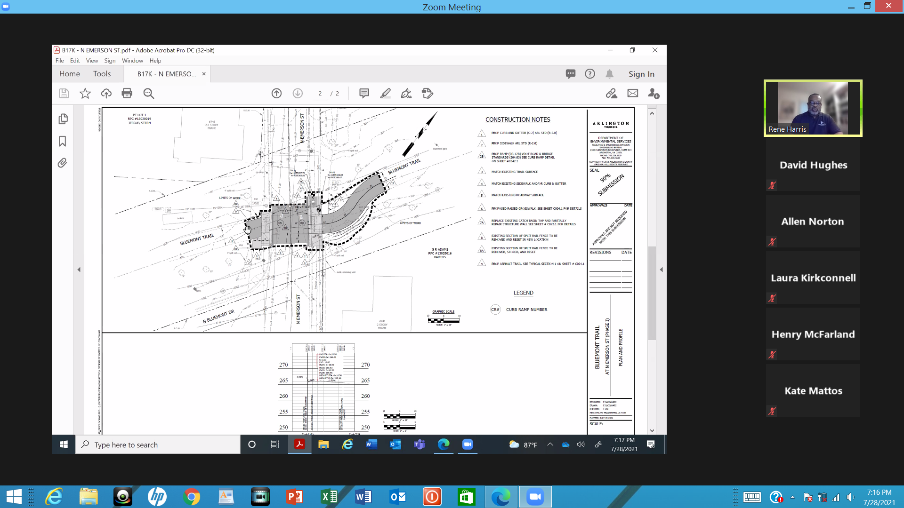

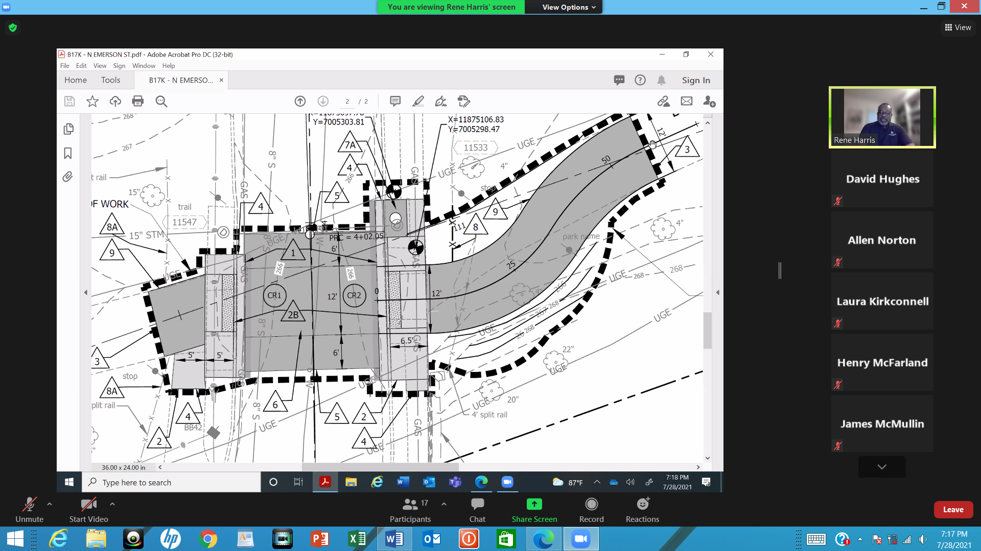

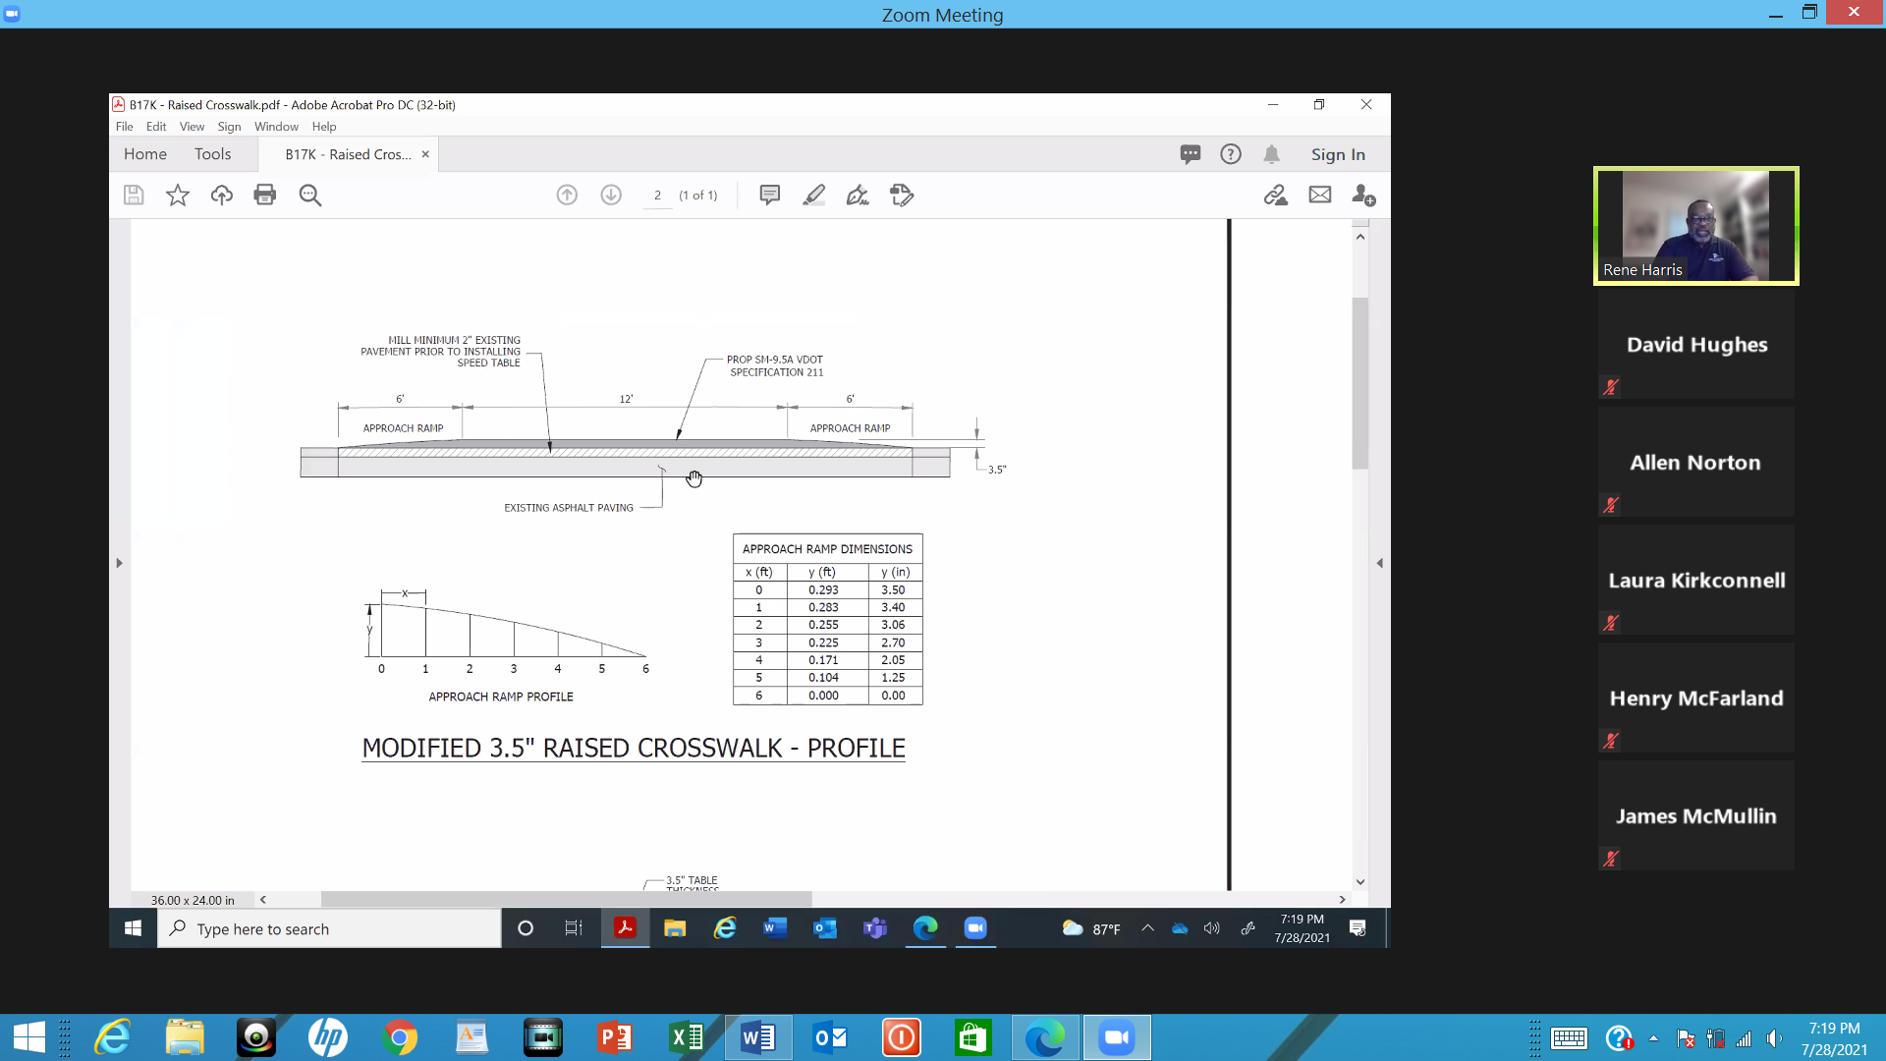

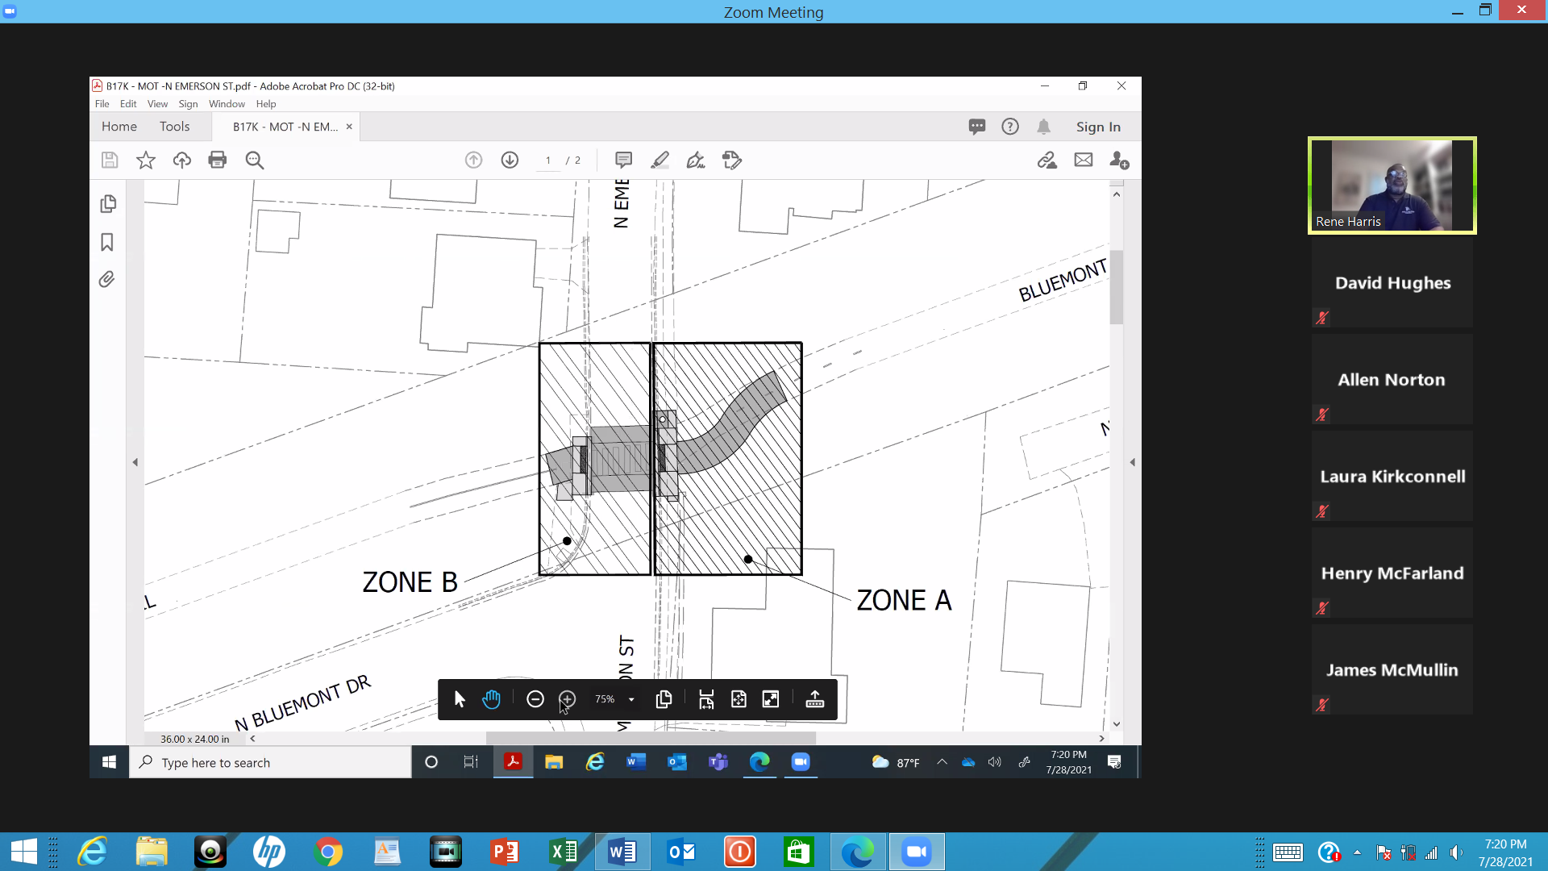

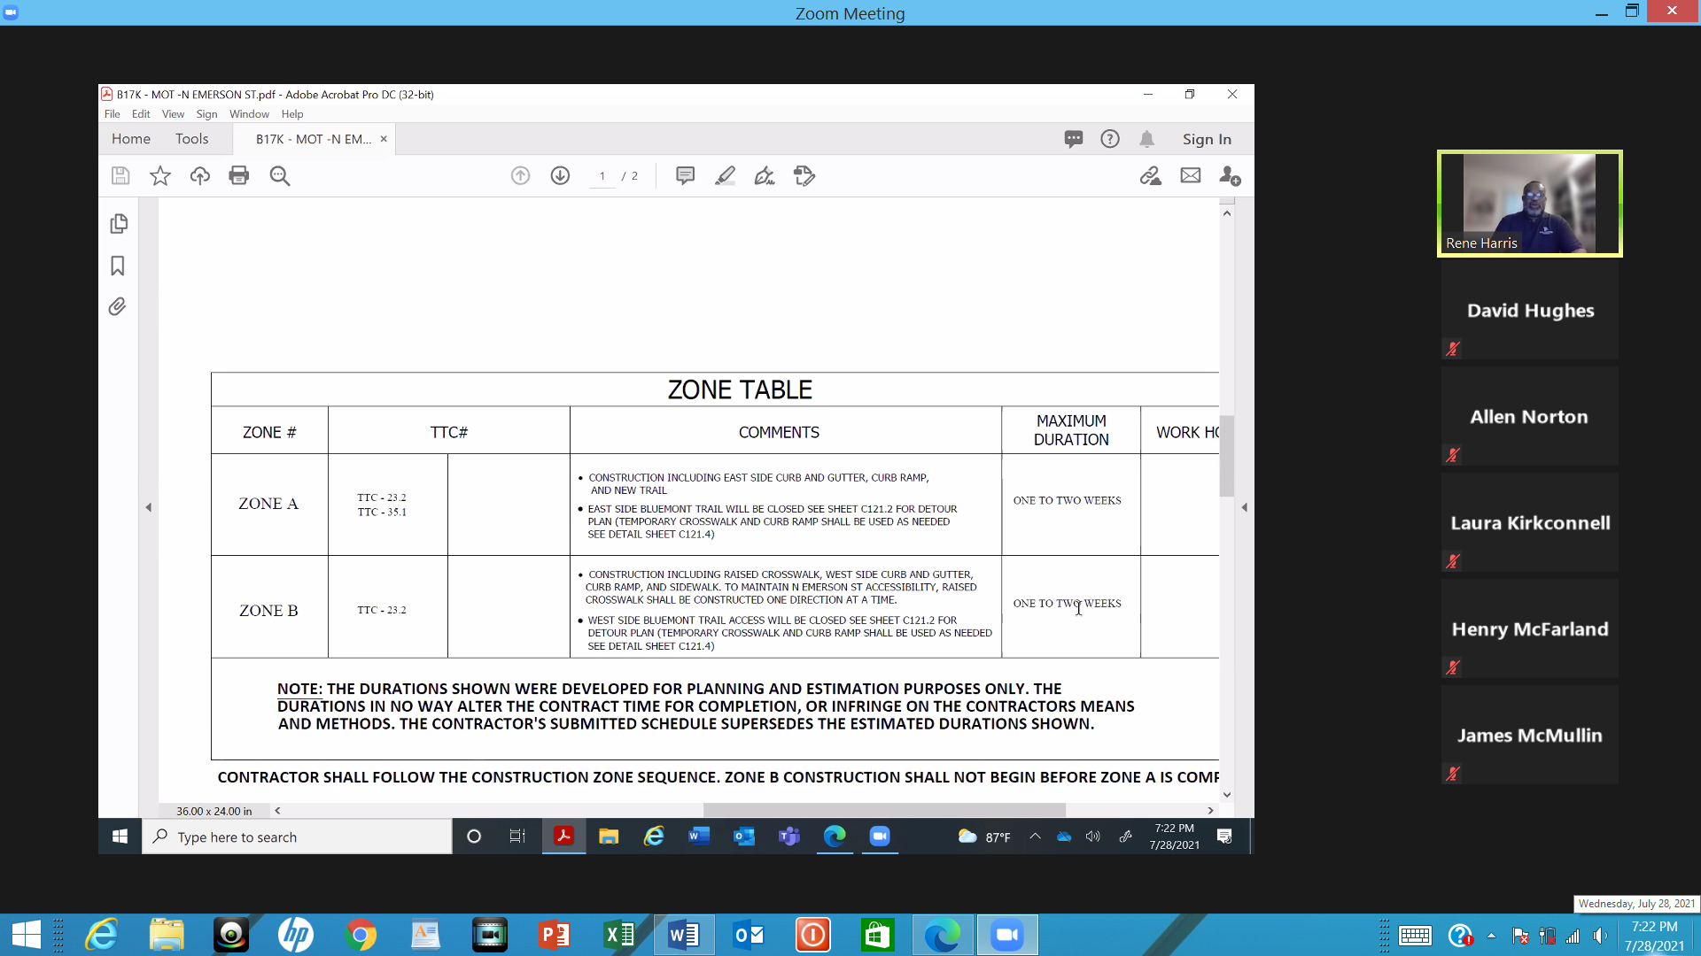

Each phase will take one to two weeks to complete. As currently planned, the first phase work will be on Zone A. The second phase (Zone B) will be performed one traffic lane at a time. It will necessitate detours. There is no planned change for the lighting at the intersection. The school bus stop may be inaccessible for a short period of time. Other than the raised median, there are no additional plans for “traffic calming” at the intersection. Mr. Harris entertained and answered several questions from residents in attendance.

Unfinished Business:

(a) Lubber Run flooding risk:

Concerning flooding risks associated with the open channel of Lubber Run along the west side of the 500-700 blocks of N. Abingdon Street, there was a discussion summarizing the community meeting that the County hosted virtually. Bottom line: County officials said maintenance of, and improvement to, the channel are funding issues and the County’s capacity to act is limited by the appropriations available. It was recommended that BCA lobby for inclusion of the channel in the County’s negotiations that start in October regarding which capital improvement projects should be included in the list of projects to be funded by a capital improvement bond. The President recommended work start now on a resolution to be presented for members’ consideration at the next General Membership meeting (in September) that BCA should encourage the open channel be included in the bond.

(b) Bluemont Junction Trail Signage:

The President reported that Bob Upton from the County park management has e-mailed to say signs under control of park management will be removed during milling and repaving of the Trail, then replaced; and that he had referred community concerns about the location and height of the “wayfinding signs” to the Department of Environment Services traffic division. Per an e-mail from the County Manager’s Office, DES will evaluate the signs’ location and height against existing DES standards, recognizing that there may be a need to relocate some of the signs. This may occur simultaneously with milling and paving work scheduled for Bluemont Junction Trail.

(c) Truck Traffic on Tazewell Street:

The President reminded the Board that during the June 30 General Membership meeting, members discussed plans to proposed a resolution at the September 29 General Membership meeting to remind Saul Centers (owners & managers of The Waycroft) of their commitment to have delivery trucks access the primary loading dock using the left turn from northbound Glebe road onto N. 7th Street. Saul Centers had noted in an e-mail to a neighbor that the smaller N. Tazewell Street loading dock will service Silver Diner and Waycroft residents.

New Business

(a) What would Board Members like to see BCA doing over the next year:

The Second Vice President initiated a discussion on the need to recruit new Board members. Various options (a neighborhood social event, use of Nextdoor, use of school bulletin boards) were proffered.

The Second Vice President also recommended offering training for new Board members. The President and Second Vice President agreed to meet to discuss such training.

Other priorities were flooding prevention, mitigating flooding risk, and better enforcement of the County’s building and zoning codes.

(b) Virtual vs. in-person meetings:

The Board reviewed the County’s e-mail response that it may have information in September 2021 about County guidance for in-person meetings using County facilities. It is understood that the state of community spread of the virus and its variants will largely control the question of whether public health authorities will give the go-ahead for large in-person gatherings within County facilities. Outgoing Treasurer Dave Van Wagner had offered to contact Lubber Run Community Center about the use of conference rooms within that facility for BCA meetings, given that health concerns for elementary schools may pose additional concerns about public meetings at the elementary school where BCA met prior to the pandemic.

(c) Construction project:

Regarding 733 N. Emerson Street, adjacent homeowners and the builder and made brief statements. The builder offered to discuss the construction directly with neighbors.

(d) Flooding concerns from Langston Blvd (formerly Lee Highway) redevelopment:

The Board discussed County staff is examining to what extent the development plan for Route 29 (“Langston Boulevard”/formerly “Lee Highway”) might affect areas within the northern portion of the watershed of Lubber Run and, ultimately, residents of Bluemont. The President mentioned that it might merit checking with County Board Member Garvey given her statements at a BCA General Membership meeting that the County needed to improve its regulations to deal with development on one property increasing flooding risk and storm water problems for other properties.

(e) Arlington County Civic Federation subcommittee:

Treasurer, and BCA Alternate Civic Federation Delegate, David Smith offered that he will seek to join the Civic Federation Stormwater Management Committee Subcommittee.

(f) VDOT safety study:

The President noted that, after consultation with the Board, she had provided herself as the POC requested by VDOT a community meeting in the autumn on a Route 50 and Manchester Street Operations and Safety Study. The President is currently performing that function but is seeking a resident that might have more knowledge about this problematic intersection.

(g) League of Women Voters voter registration:

The Second Vice President volunteered to be the POC for BCA vis-à-vis the League of Women Voters, which had requested a POC in connection with its nonpartisan in-person voter registration program for Bluemont. The Second Vice President will report to the General Membership at the September meeting to seek their approval for continuing BCA’s cooperation with the League.

The President adjourned the meeting at 8:55 pm.

