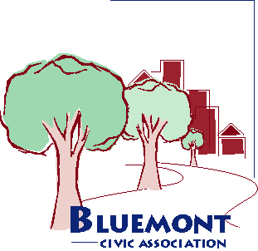Bluemont Civic Association
Representing Neighborhoods in and around Arlington Traditional School, Lacey Woods Park, Bon Air, Fields Park, Balls Crossing, West Ballston, and all along the former Bluemont Division of the Washington and Old Dominion Railroad

P.O. Box 5134 Arlington, Virginia 22205
www.bluemontcivic.org

Minutes Executive Board Meeting, November 16, 2022, 7:00 pm

Via Zoom and in Key Escuela School Library

1. The President established that a quorum was present.

2. Members approved minutes of the October 2022 Executive Board meeting with no changes.
3. Reports from Officers and Committee Chairs
President Henry McFarland discussed changes to the Macy’s Site Plan review, which include reduced impervious surfaces, turning restrictions, light timing for better visibility of pedestrians, and reconfiguration of the alley by Macy’s. Other issues that are being considered are parking for residents and the grocery store and obstruction of views. The goal is for construction to be completed in 2027.

The President reported that consultations are underway concerning a potential new park at N. Harrison St. at the Route 66 overpass. There is currently a garden there that is maintained by a neighbor, which the President understands is allowed as long as the garden is open to the public.

The President reported that County Board members de Ferranti and Garvey have expressed support for a compromise on the Missing Middle project that would allow the by-right building of up to 6 units.

The President reported that the Halloween Parade was a success and suggested that it be repeated in the future. He expressed his appreciation to all who helped, especially the Cochranes of Dovetail Properties & Design, who sponsored the event. He noted that several neighbors joined BCA at the parade.

The Treasurer reported that the BCA bank account’s balance was $1,763.28, unchanged from the last meeting, although several dues checks must be deposited or may not have cleared yet.

The Arlington Neighborhoods Advisory Committee (ArNAC, formerly NCAC) representative reported that at the last meeting, the main topic was making the submissions process easier. A County staff member advised that a written proposal is needed to put the N. Carlin Springs project into the queue.

The Civic Federation delegate reported that the Task Force in Governance and Election Reform (TiGER) resolution passed concerning increasing the County Board from 5 to 7 members; proposing rank choice voting for all contests, not merely primaries; paying Board members a full-time rather than part-time salary; and bringing back the “Arlington Way,” which involved extensive consultation.

The President noted his understanding that a BCA Zoom account would need to be linked to a single individual and that he was still looking for ideas to make setting up an account possible.

The President suggested an inclement weather policy for the holiday bell-ringing. If it’s raining at 11:00, then the bell-ringing should be cancelled.

4. Adjourned at approximately 7:25 pm

Minutes prepared by Dorothy Patton

